

**Module Code & Module Title**

CC6001NA Advance Database System Development

**Assessment Weightage & Type**

40% Individual Coursework

**Year and Semester**

2019-20 Autumn

**Student Name:** Pranaya Pradhan

**London Met ID:** 17030952

**College ID:** np01cp4a170020

**Assignment Due Date:** 31st January 2020

**Assignment Submission Date:** 31st January 2020

*I confirm that I understand my coursework needs to be submitted online via Google Classroom under the relevant module page before the deadline for my assignment to be accepted and marked. I am fully aware that late submissions will be treated as non-submission and a mark of zero will be awarded.*

Table of Contents

1. Introduction 1

2. Normalization 2

2.1. Normalization of Figure 1 2

2.1.1. Assumptions 2

2.2. Normalization of Figure 2 4

2.2.1. Assumption 4

3. ERD Model 6

4. Data Dictionary 7

5. Generation of Database 8

5.1. Create Statements: 8

5.2. Insert Statements: 13

5.3. Select Statements: 21

6. Implementation of Web-Based Database Application 22

6.1. Basic Web forms 22

6.1.1. Dashboard (dashboard.aspx) 22

6.1.2. Staff Details 22

6.1.3. Designation Details 23

6.1.4. Customer Details 23

6.1.5. Package Details 24

6.1.6. Tour Guide Details 24

6.2. Customer-Package Schedule Form 25

6.3. Staff-Role Schedule Form 25

6.4. Package-Activity Schedule Form 26

7. Testing 27

7.1. Staff Details 27

7.1.1. Inserting data in Staff Details 27

7.1.2. Updating the Data of Grid View 29

7.1.3. Deleting the Data of Grid View 30

7.2. Designation Form 32

7.2.1. Inserting Data in Designation Form 32

7.2.2. Updating the Data in Designation Form 33

7.2.3. Deleting the Data in Designation Form 34

7.3. Customer Form 35

7.3.1. Inserting Data in Customer Form 35

7.3.2. Updating the Data in Customer Form 36

7.3.3. Deleting the in Customer Form 37

7.4. Package Form 38

7.4.1. Inserting Data in Package Form 38

7.4.2. Updating the Data in Package Form 39

7.4.3. Deleting the Package Form 40

7.5. Tour Guide Form 41

7.5.1. Inserting Data in Tour Guide Form 41

7.5.2. Updating the Data in TourGuide Form 42

7.5.3. Deleting the in Tour Guide Form 43

8. Further Discussion 44

Table of Figure

Figure 1 Figure of ERD Model 6

Figure 2 Data Dictionary of the System 7

Figure 3 Screenshot of Dashboard 22

Figure 4 Screenshot of Staff Details Form 22

Figure 5 Screenshot of Designation Details Form 23

Figure 6 Screenshot of Customer Details Form 23

Figure 7 Screenshot of Package Details Form 24

Figure 8 Screenshot of Tour Guide Form 24

Figure 9 Customer-Package Schedule Form 25

Figure 10 Staff-Role Schedule Form 25

Figure 11 Package-Activity Schedule Form 26

Figure 12 Inserting Data in Customer Text Field 27

Figure 13 Data Filled in Customer Form Text Field 27

Figure 14 Grid View After Inserting New Data in Customer Form 28

Figure 15 Grid View of Staff Form before Updating the data 29

Figure 16 Updating Data in Staff Form 29

Figure 17 Grid View After Updating the data in Staff Form 30

Figure 18 Clicking the Delete button 30

Figure 19 Grid View After Deleting the Data 31

Figure 20 Entering the value in Text Field of Designation Form 32

Figure 21 Grid View of Designation Form After Inserting the Data 32

Figure 22 Clicking the Edit Button in Designation Form 33

Figure 23 Updating the Data in Designation Form 33

Figure 24 Grid View After Updating the Data 33

Figure 25 Clicking the Delete Button in Designation Form 34

Figure 26 Grid View After Deleting the data in Designation Form 34

Figure 27 Entering the Data in Text Field of Customer Form 35

Figure 28 Grid View After Adding New Data in Customer Form 35

Figure 29 Clicking the Edit Button in Customer Form 36

Figure 30 Updating the Data in Grid View of Customer Form 36

Figure 31 Grid View After Updating the Data in Customer Form 36

Figure 32 Clicking the Delete Button in Customer Form 37

Figure 33 Grid View After Deleting the Data in Customer Form 37

Figure 34 Entering the Data in Text Field of Package Form 38

Figure 35 Grid View After Inserting New Data in Package Form 38

Figure 36 Clicking on Edit Button 39

Figure 37 Updating the Data in Grid View of Package Form 39

Figure 38 Grid View After Updating the Data in Package Form 39

Figure 39 Clicking on Delete Button 40

Figure 40 Grid View After Deleting the Data in Package Form 40

Figure 41 Entering the data in Text Field of TourGuide Forms 41

Figure 42 Grid View After Adding Data in TourGuide Form 41

Figure 43 Clicking on Edit Button 42

Figure 44 Grid View After Updating the Data on TourGuide Form 42

Figure 45 Clicking on Delete Button 43

Figure 46 Grid View After Deleting the Data in TourGuide Form 43

# 1. Introduction

For the very first coursework assignment which is an individual assessment weighted 40% of the marks for the module. It is designed mainly to assess students’ practical problem-solving skills and critical thinking/evaluation on the design and development of database systems. It requires an analyse, design and implement a web-based database application based on a given business case study. I have been asked to provide a software solution as well as appropriate documentation detailing the design and implementation of the system. Further Discussion has been made in order to which should summarise your experience in undertaking this coursework with Mention of 5 tools/techniques learnt during course work. All output including diagrams, tables, forms, SQL scripts clearly labelled and presented.

# 2. Normalization

## 2.1. Normalization of Figure 1

### 2.1.1. Assumptions

The following are the assumption of figure 1

* Destination has its Destination id.
* Destination-id and Destination are repeating groups.

The following normalization of Package Record:

|  |  |  |  |  |
| --- | --- | --- | --- | --- |
| Package ID | Package Name | Destination | Total No of Days | Difficulty |
| LK25A | ABC | Annapurna Base Camp | 7 | Moderate |
| UI32A | Ghandruk | Ghandruk, Pokhara | 4 | Moderate |
| NB34G | Everest Short Trek | Lukla, Khumjung | 4 | Hard |

Table 1Table of Package Record

**UNF**

Package (package-id, package name, total no of days, difficulty, {destination-id, destination})

**1NF**

* **Removing Repeating Group**

**Tables**

Package-1(**package-id**, package name, total no of days, difficulty)

PackageDestination-1(**package-id, destination-id,** destination)

**2NF**

* **Removing Partial Dependency**

package-id ->

package-id, destination->

destination->

**Tables**

**Package2**(**package-id**, package name, total no of days, difficulty)

**PackageDestination2**(**package-id, destination-id**)

**Destination2**(**destination-id,** destination)

**3NF**

* **Removing Transitive Dependency**

Since there is not transitive dependency. It is in 3NF.

**Package3**(**package-id**, package name, total no of days, difficulty)

**PackageDestination3**(**package-id, destination-id**)

**Destination3(destination-id,** destination**)**

## 2.2. **Normalization of Figure 2**

### 2.2.1. Assumption

The following are the assumptions for the normalization of figure 2:

* Every Tour Package will have its own package id.
* Every package has number days to travel. So the day and package id are depending to each other.
* In every package it will have many activities which is identified by activities id. So the activity id is depending on package id and day.
* Travel Mode depends on activities.

**UNF**

**Tracking-Record (**package-id, package-name, start-date, end-date, tour-guide {day, travel-details {activities-id, activities, travel-mode, status}, difficulty-mode}**)**

**1NF**

**Removing Repeating Group**

**TrackingRecord1(package-id,** package-name, start-date, end-date, tour-guide**)**

**PackageDays1(package-id, day,** travel-details, difficulty-mode**)**

**PackageActivity1(package-id, day, activity-id,** activities, travel-mode, status**)**

**2NF**

**Removing Partial Dependency**

**package-id ->**

**package-id, day ->** travel-details, difficulty-mode

**day->**

**activity_id->** activities

**package-id, day, activity-id ->** activities, travel-mode, status

**Tracking-Record2(package-id**,package-name, start-date, end-date, tour-guide**) PackageDays2(package-id, day,** travel-details, difficulty-mode**) PackageActivity2(package-id, day, activity-id,** travel-mode, status**)**

**Activity2(activity-id,** activities)

**3NF**

**No Transitive Dependency**

**Tracking-Record3(package-id,** package-name, start-date, end-date, tour-guide**)**

**PackageDays3(package-id, day,** travel-details, difficulty-mode**)**

**PackageActivity3(package-id, day, activity-id,** travel-mode, status**)**

**Activity3(activity-id,** activities**)**

# 3. ERD Model

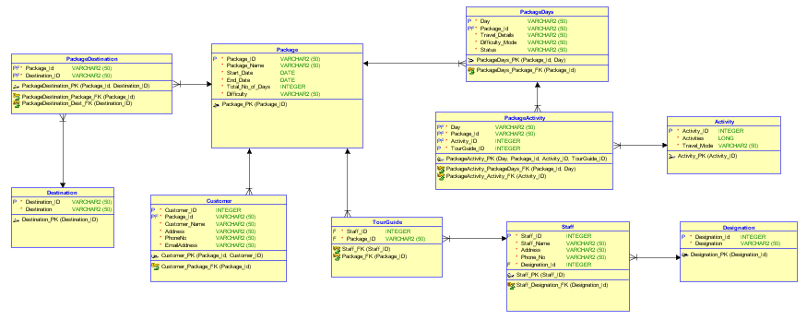

Figure 1 Figure of ERD Model

# 4. Data Dictionary

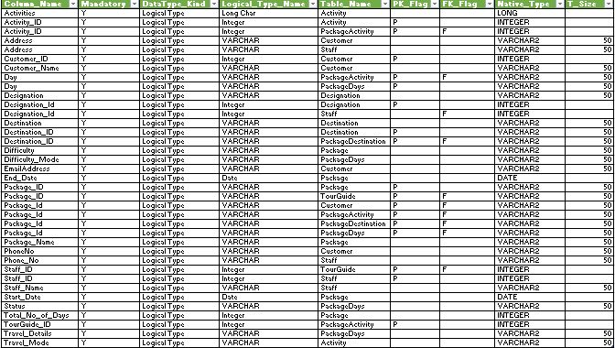

Figure 2 Data Dictionary of the System

# 5. Generation of Database

## 5.1. Create Statements:

CREATE TABLE Activity

(

Activity_ID INTEGER NOT NULL ,

Activities LONG NOT NULL ,

Travel_Mode VARCHAR2 (50) NOT NULL

) ;

ALTER TABLE Activity ADD CONSTRAINT Activity_PK PRIMARY KEY ( Activity_ID ) ;

CREATE TABLE Customer

(

Customer_ID INTEGER NOT NULL ,

Package_Id VARCHAR2 (50) NOT NULL ,

Customer_Name VARCHAR2 (50) NOT NULL ,

Address VARCHAR2 (50) NOT NULL ,

PhoneNo VARCHAR2 (50) NOT NULL ,

EmailAddress VARCHAR2 (50) NOT NULL

) ;

ALTER TABLE Customer ADD CONSTRAINT Customer_PK PRIMARY KEY ( Package_Id, Customer_ID ) ;

CREATE TABLE Designation

(

Designation_Id INTEGER NOT NULL ,

Designation VARCHAR2 (50) NOT NULL

) ;

ALTER TABLE Designation ADD CONSTRAINT Designation_PK PRIMARY KEY ( Designation_Id ) ;

CREATE TABLE Destination

(

Destination_ID VARCHAR2 (50) NOT NULL ,

Destination VARCHAR2 (50) NOT NULL

) ;

ALTER TABLE Destination ADD CONSTRAINT Destination_PK PRIMARY KEY ( Destination_ID ) ;

CREATE TABLE PACKAGE

(

Package_ID VARCHAR2 (50) NOT NULL ,

Package_Name VARCHAR2 (50) NOT NULL ,

Start_Date DATE NOT NULL ,

End_Date DATE NOT NULL ,

Total_No_of_Days INTEGER NOT NULL ,

Difficulty VARCHAR2 (50) NOT NULL

) ;

ALTER TABLE

PACKAGE ADD CONSTRAINT Package_PK PRIMARY KEY(

Package_ID ) ;

CREATE TABLE PackageActivity

(

DAY VARCHAR2 (50) NOT NULL ,

Package_Id VARCHAR2 (50) NOT NULL ,

Activity_ID INTEGER NOT NULL ,

TourGuide_ID INTEGER NOT NULL

) ;

ALTER TABLE PackageActivity ADD CONSTRAINT PackageActivity_PK PRIMARY KEY ( DAY, Package_Id, Activity_ID, TourGuide_ID ) ;

CREATE TABLE PackageDays

(

DAY VARCHAR2 (50) NOT NULL ,

Package_Id VARCHAR2 (50) NOT NULL ,

Travel_Details VARCHAR2 (50) NOT NULL ,

Difficulty_Mode VARCHAR2 (50) NOT NULL ,

Status VARCHAR2 (50) NOT NULL

) ;

ALTER TABLE PackageDays ADD CONSTRAINT PackageDays_PK PRIMARY KEY ( Package_Id, DAY ) ;

CREATE TABLE PackageDestination

(

Package_Id VARCHAR2 (50) NOT NULL ,

Destination_ID VARCHAR2 (50) NOT NULL

) ;

ALTER TABLE PackageDestination ADD CONSTRAINT PackageDestination_PK PRIMARY KEY ( Package_Id, Destination_ID ) ;

CREATE TABLE Staff

(

Staff_ID INTEGER NOT NULL ,

Staff_Name VARCHAR2 (50) NOT NULL ,

Address VARCHAR2 (50) NOT NULL ,

Phone_No VARCHAR2 (50) NOT NULL ,

Designation_Id INTEGER NOT NULL

) ;

ALTER TABLE Staff ADD CONSTRAINT Staff_PK PRIMARY KEY ( Staff_ID ) ;

CREATE TABLE TourGuide

(

Staff_ID INTEGER NOT NULL ,

Package_ID VARCHAR2 (50) NOT NULL

) ;

ALTER TABLE TourGuide ADD CONSTRAINT TourGuide_PK PRIMARY KEY ( Staff_ID, Package_ID ) ;

ALTER TABLE Customer ADD CONSTRAINT Customer_Package_FK FOREIGN KEY ( Package_Id ) REFERENCES

PACKAGE(

Package_ID ) ;

ALTER TABLE PackageActivity ADD CONSTRAINT PackageActivity_Activity_FK FOREIGN KEY ( Activity_ID ) REFERENCES Activity ( Activity_ID ) ;

ALTER TABLE PackageActivity ADD CONSTRAINT PackageActivity_PackageDays_FK FOREIGN KEY ( Package_Id, DAY ) REFERENCES PackageDays ( Package_Id, DAY ) ;

ALTER TABLE PackageDays ADD CONSTRAINT PackageDays_Package_FK FOREIGN KEY ( Package_Id ) REFERENCES

PACKAGE(

Package_ID ) ;

ALTER TABLE PackageDestination ADD CONSTRAINT PackageDestination_Dest_FK FOREIGN KEY ( Destination_ID ) REFERENCES Destination ( Destination_ID ) ;

ALTER TABLE PackageDestination ADD CONSTRAINT PackageDestination_Package_FK FOREIGN KEY ( Package_Id ) REFERENCES

PACKAGE(

Package_ID ) ;

ALTER TABLE TourGuide ADD CONSTRAINT Package_FK FOREIGN KEY ( Package_ID ) REFERENCES

PACKAGE(

Package_ID ) ;

ALTER TABLE Staff ADD CONSTRAINT Staff_Designation_FK FOREIGN KEY ( Designation_Id ) REFERENCES Designation ( Designation_Id ) ;

ALTER TABLE TourGuide ADD CONSTRAINT Staff_FK FOREIGN KEY ( Staff_ID ) REFERENCES Staff ( Staff_ID ) ;

## 5.2. Insert Statements:

#Designation

INSERT INTO Designation VALUES (1, 'Tour Guide');

INSERT INTO Designation VALUES (2, 'Travel Agent');

INSERT INTO Designation VALUES (3, 'Receptionist');

INSERT INTO Designation VALUES (4, 'Accountant');

INSERT INTO Designation VALUES (5, 'IT Director');

#Staff

INSERT INTO Staff VALUES (1, 'Ananta Tamang', 'Kathmandu','9851025639',1);

INSERT INTO Staff VALUES (2, 'Biraj Maharjan', 'Kathmandu','984108597',1);

INSERT INTO Staff VALUES (3, 'Alan Neupane', 'Hetauda', '9851025639',1);

INSERT INTO Staff VALUES (4, 'Santosh Shahukhala', 'Lalitpur', '9851037096',1);

INSERT INTO Staff VALUES (5, 'Kamal Shrestha', 'Kathmandu', '9841025369',2);

INSERT INTO Staff VALUES (6, 'Rejin Subba', 'Kathmandu', '9849078956',2);

INSERT INTO Staff VALUES (7, 'Abhishek Rijal', 'Nuwakot', '9849078596',3);

INSERT INTO Staff VALUES (8, 'Rupesh KC', 'Nuwakot', '9802578569',3);

INSERT INTO Staff VALUES (9, 'Sunil Bal', 'Lalitpur', '9841258963',4);

INSERT INTO Staff VALUES (10, 'Bikesh Kuthu', 'Bhaktapur', '9843609875',4);

INSERT INTO Staff VALUES (11, 'Dinesh Rajbanshi', 'Lalitpur', '9836789545',5);

INSERT INTO Staff VALUES (12, 'Bishal Shrestha', 'Kathmandu', '9851084957',5);

#Package

INSERT INTO Package VALUES ('PK1','Pokhara', '10-Jan-2020', '15-Jan-2020', 5,'Easy');

INSERT INTO Package VALUES ('PK2', 'Mt.Everst', '12-Jan-2020', '25-Jan-2020', 13, 'Hard');

INSERT INTO Package VALUES ('PK3', 'ABC', '1-Feb-2020', '7-Feb-2020', 7, 'Moderate');

INSERT INTO Package VALUES ('PK4', 'Ghandruk', '10-Feb-2020', '14-Feb-2020', 4, 'Moderate');

INSERT INTO Package VALUES ('PK5', 'Lumbini', '20-Feb-2020', '24-Feb-2020', 5, 'Easy');

#Destination

INSERT INTO destination VALUES (1, 'Pokhara');

INSERT INTO destination VALUES (2, 'Mt.Everest');

INSERT INTO destination VALUES (3, 'ABC');

INSERT INTO destination VALUES (4,'Ghandruk');

INSERT INTO destination VALUES (5,'Lumbini');

#Customer

INSERT INTO Customer VALUES (1, 'PK1', 'Arun Man Joshi', 'Tripureshwor', '9851055037', 'joshiarunman@gmail.com');

INSERT INTO Customer VALUES (2, 'PK1', 'Sanjib Shilpakar', 'Mangal Bazar', '9851037368', 'sanjibsports@gmail.com');

INSERT INTO Customer VALUES (3, 'PK2', 'Meghraj KC', 'Bhanimandal', '9851028178', 'kcmegraj@gmail.com');

INSERT INTO Customer VALUES (4, 'PK2', 'Mangal Maharjan', 'Gwarko', '9841468250', 'mangalm@gmail.com');

INSERT INTO Customer VALUES (5, 'PK3', 'Ram Shrestha Boss', 'Bhaisipati', '9851859674', 'ram.bossgmail.com');

INSERT INTO Customer VALUES (6, 'PK3', 'Mukesh Nakarmi', 'Sundhara', '9851859674', 'mukeshnakarmi01@gmail.com');

INSERT INTO Customer VALUES (7, 'PK4', 'Krishna Awale', 'Thecho', '9851055063', 'awalekrishna@gmail.com');

INSERT INTO Customer VALUES (8, 'PK4', 'Utsav Shakya', 'Kupondole', '9843608596', 'utsavs@gmail.com');

INSERT INTO Customer VALUES (9, 'PK5', 'Mikchhen Tamang', 'Hattiban', '9841589677', 'tamangmikcchen@gmail.com');

INSERT INTO Customer VALUES (10,'PK5', 'Bikram Lama', 'Chayasal', '9841859674', 'lamabikram@gmail.com');

#Tour Guide

INSERT INTO TourGuide VALUES (1, 'PK1');

INSERT INTO TourGuide VALUES (2, 'PK2');

INSERT INTO TourGuide VALUES (3, 'PK3');

INSERT INTO TourGuide VALUES (4, 'PK4');

INSERT INTO TourGuide VALUES (1, 'PK5');

#PackageDestination

INSERT INTO PackageDestination VALUES ('PK1', 1);

INSERT INTO PackageDestination VALUES ('PK2', 2);

INSERT INTO PackageDestination VALUES ('PK3', 3);

INSERT INTO PackageDestination VALUES ('PK4', 4);

INSERT INTO PackageDestination VALUES ('PK5', 5);

#Activity

INSERT INTO Activity VALUES (1, 'Driving to Destination from Kathmandu', 'Bus');

INSERT INTO Activity VALUES (2, 'Fully day Sightseeing in Pokhara and enjoy boating in Phewa Lake', 'Bus/Walk/Boating');

INSERT INTO Activity VALUES (3, 'Visit Tal Barahi Temple and market visit', 'Bus/Walk');

INSERT INTO Activity VALUES (4, 'Driving back to Kathmandu', 'Bus');

INSERT INTO Activity VALUES (5, 'Fly Kathmandu to Lukla. Trek to Phadking', 'Flight/Walk');

INSERT INTO Activity VALUES (6,'Trek from Phadking to Namche Bazaar','Walk');

INSERT INTO Activity VALUES (7,'Acclimatization day in Namche Bazaar', 'Walk');

INSERT INTO Activity VALUES (8,'Trek from Namche Bazaar to Tengboche', 'Walk');

INSERT INTO Activity VALUES (9, 'Trek from Tengboche to Periche', 'Walk');

INSERT INTO Activity VALUES (10, 'Acclimitization Day. Potentially Trek from Pheriche to Dingboche', 'Walk');

INSERT INTO Activity VALUES (11, 'Trek from Pheriche to Lobuche', 'Walk');

INSERT INTO Activity VALUES (12,'Hike from Lobuche to Gorak Shep', 'Walk');

INSERT INTO Activity VALUES (13, 'Gorak Shep to Kala Patthar, then onto Dingboche', 'Walk');

INSERT INTO Activity VALUES (14, 'Hike back to Namche Bazaar from Dingbocheg', 'Walk');

INSERT INTO Activity VALUES (15, 'Hike from Namche Bazaar to Lukla', 'Walk');

INSERT INTO Activity VALUES (16, 'Fly back from Lukla to Kathmandu', 'Flight/Walk');

INSERT INTO Activity VALUES (17, 'Drive to Nayapul and trek to Ghandruk', 'Bus/Walk');

INSERT INTO Activity VALUES (18, 'Trek from Ghandruk to Sinuwa', 'Walk');

INSERT INTO Activity VALUES (19, 'Trek from Sinuwa to Deurali', 'Walk');

INSERT INTO Activity VALUES (20, 'Trek from Deurali to Annapurna', 'Walk');

INSERT INTO Activity VALUES (21, 'Trek from Annapurna Base Camp to Bamboo', 'Walk');

INSERT INTO Activity VALUES (22, 'Trek from Bamboo to Jhinu Hot Spring', 'Walk');

INSERT INTO Activity VALUES (23,'Trek from Jhinu Hot Spring to Nayapul and Drive to Pokhara', 'Walk/Bus');

INSERT INTO Activity VALUES (24,'Trek to Ghandruk, plore the Ghandruk Village', 'Bus/Walk');

INSERT INTO Activity VALUES (25,'View the beautiful sunrise and Himalayas. Trek Down to Pokhara', 'Bus/Walk');

INSERT INTO Activity VALUES (26,'Drive from Kathmandu to Lumbini', 'Bus');

INSERT INTO Activity VALUES (27,'Lumbini Garden for worship', 'Walk');

INSERT INTO Activity VALUES (28,'Drive to Tilaurakot (Kapilvastu) covering major shrines such as: Gotihawa, Niglihawa and Kundan', 'Bus/Walk');

INSERT INTO Activity VALUES (29,'Drive from Lumbini to Kathmandu', 'Bus');

#PackageDays

INSERT INTO PackageDays VALUES ('Day1', 'PK1', 'Kathmandu to Pokhara', 'Moderate','Complete');

INSERT INTO PackageDays VALUES ('Day2', 'PK1', 'Stay in Pokhara', 'Easy', 'Complete');

INSERT INTO PackageDays VALUES ('Day3', 'PK1', 'Stay in Pokhara', 'Easy', 'Complete');

INSERT INTO PackageDays VALUES ('Day4', 'PK1', 'Pokhara to Kathmandu', 'Moderate', 'Complete');

INSERT INTO PackageDays VALUES ('Day1', 'PK2', 'Kathmandu to Lukla', 'Easy', 'Complete');

INSERT INTO PackageDays VALUES ('Day2', 'PK2', 'Phadking to Namche Bazar', 'Moderate',

'Complete');

INSERT INTO PackageDays VALUES ('Day3', 'PK2', 'Staying in Namche Bazar', 'Easy',

'Complete');

INSERT INTO PackageDays VALUES ('Day4', 'PK2', 'Namche to Tengboche', 'Hard',

'Complete');

INSERT INTO PackageDays VALUES ('Day5', 'PK2', 'Tengboche to Dingboche', 'Hard',

'Complete');;

INSERT INTO PackageDays VALUES ('Day6', 'PK2', 'Dingboche to Pheriche', 'Hard',

'Complete');

INSERT INTO PackageDays VALUES ('Day7', 'PK2', 'Pheriche to Lobuche', 'Hard',

'Complete');

INSERT INTO PackageDays VALUES ('Day8', 'PK2', 'Lobuche to Gorak Shep', 'Hard',

'Complete');

INSERT INTO PackageDays VALUES ('Day9', 'PK2', 'Gorak Shep to Kala Patthar, then onto Dingboche', 'Hard',

'Complete');

INSERT INTO PackageDays VALUES ('Day10', 'PK2', 'Dingboche to NamcheBazar', 'Hard',

'Complete');

INSERT INTO PackageDays VALUES ('Day11', 'PK2', 'NamcheBazar to Lukla', 'Hard',

'Complete');

INSERT INTO PackageDays VALUES ('Day12', 'PK2', 'Lukla to Kathmandu', 'Moderate',

'Complete');

INSERT INTO PackageDays VALUES ('Day1', 'PK3', 'Kathmandu to Pokhara', 'Easy', 'Remaining');

INSERT INTO PackageDays VALUES ('Day2', 'PK3', 'Pokhara to Nayapul', 'Moderate', 'Remaining');

INSERT INTO PackageDays VALUES ('Day3', 'PK3', 'Nayapul to Ghandruk', 'Hard', 'Remaining');

INSERT INTO PackageDays VALUES ('Day4', 'PK3', 'Ghandruk to Sinuwa', 'Hard', 'Remaining');

INSERT INTO PackageDays VALUES ('Day5', 'PK3', 'Sinuwa to Deurali', 'Hard', 'Remaining');

INSERT INTO PackageDays VALUES ('Day6', 'PK3', 'Deurali to Annapurna Base Camp', 'Hard', 'Remaining');

INSERT INTO PackageDays VALUES ('Day7', 'PK3', 'Annapurna Base Camp to Bamboo', 'Hard', 'Remaining');

INSERT INTO PackageDays VALUES ('Day8', 'PK3', 'Bamboo to Jhinu Hot Spring', 'Hard', 'Remaining');

INSERT INTO PackageDays VALUES ('Day9', 'PK3', 'Jhinu Hot Spring to Nayapul', 'Hard', 'Remaining');

INSERT INTO PackageDays VALUES ('Day10', 'PK3', 'Nayapul to Pokhara', 'Moderate', 'Remaining');

INSERT INTO PackageDays VALUES ('Day11', 'PK3', 'Pokhara to Kathmandu', 'Easy', 'Remaining');

INSERT INTO PackageDays VALUES ('Day1', 'PK4', 'Kathmandu to Pokhara', 'Easy', 'Remaining');

INSERT INTO PackageDays VALUES ('Day2', 'PK4', 'Explore in Ghandruk', 'Moderate', 'Remaining');

INSERT INTO PackageDays VALUES ('Day3', 'PK4', 'Ghandruk to Pokhara', 'Moderate', 'Remaining');

INSERT INTO PackageDays VALUES ('Day4', 'PK4', 'Pokhara to Kathmandu', 'Easy', 'Remaining');

INSERT INTO PackageDays VALUES ('Day1', 'PK5', 'Kathmandu to Lumbini', 'Easy', 'Remaining');

INSERT INTO PackageDays VALUES ('Day2', 'PK5', 'Lumbini to Bhairahawa', 'Easy', 'Remaining');

INSERT INTO PackageDays VALUES ('Day3', 'PK5', 'Bhairahawa to Tilaurakot', 'Moderate', 'Remaining');

INSERT INTO PackageDays VALUES ('Day4', 'PK5', 'Bhairahawa to Kathmandu', 'Moderate', 'Remaining');

#PackageActivity

INSERT INTO PackageActivity VALUES ('Day1', 'PK1', 1, 1);

INSERT INTO PackageActivity VALUES ('Day2', 'PK1', 2, 1);

INSERT INTO PackageActivity VALUES ('Day3', 'PK1', 3, 1);

INSERT INTO PackageActivity VALUES ('Day4', 'PK1', 4, 1);

INSERT INTO PackageActivity VALUES ('Day1', 'PK2', 5, 2);

INSERT INTO PackageActivity VALUES ('Day2', 'PK2', 6, 2);

INSERT INTO PackageActivity VALUES ('Day3', 'PK2', 7, 2);

INSERT INTO PackageActivity VALUES ('Day4', 'PK2', 8, 2);

INSERT INTO PackageActivity VALUES ('Day5', 'PK2', 9, 2);

INSERT INTO PackageActivity VALUES ('Day6', 'PK2', 10, 2);

INSERT INTO PackageActivity VALUES ('Day7', 'PK2', 11, 2);

INSERT INTO PackageActivity VALUES ('Day8', 'PK2', 12, 2);

INSERT INTO PackageActivity VALUES ('Day9', 'PK2', 13, 2);

INSERT INTO PackageActivity VALUES ('Day10', 'PK2', 14, 2);

INSERT INTO PackageActivity VALUES ('Day11', 'PK2', 15, 2);

INSERT INTO PackageActivity VALUES ('Day12', 'PK2', 16, 2);

INSERT INTO PackageActivity VALUES ('Day1', 'PK3', 1, 3);

INSERT INTO PackageActivity VALUES ('Day2', 'PK3', 17, 3);

INSERT INTO PackageActivity VALUES ('Day3', 'PK3', 18, 3);

INSERT INTO PackageActivity VALUES ('Day4', 'PK3', 19, 3);

INSERT INTO PackageActivity VALUES ('Day5', 'PK3', 20, 3);

INSERT INTO PackageActivity VALUES ('Day6', 'PK3', 21, 3);

INSERT INTO PackageActivity VALUES ('Day7', 'PK3', 22,3);

INSERT INTO PackageActivity VALUES ('Day8', 'PK3', 23, 3);

INSERT INTO PackageActivity VALUES ('Day9', 'PK3', 4, 3);

INSERT INTO PackageActivity VALUES ('Day1', 'PK4', 1, 4);

INSERT INTO PackageActivity VALUES ('Day2', 'PK4', 24, 4);

INSERT INTO PackageActivity VALUES ('Day3', 'PK4', 25, 4);

INSERT INTO PackageActivity VALUES ('Day4','PK4',4, 4);

INSERT INTO PackageActivity VALUES ('Day1', 'PK5', 26, 1);

INSERT INTO PackageActivity VALUES ('Day2', 'PK5', 27,1);

INSERT INTO PackageActivity VALUES ('Day3', 'PK5', 28, 1);

INSERT INTO PackageActivity VALUES ('Day4', 'PK5', 29, 1);

## 5.3. Select Statements:

SELECT * FROM "STAFF"

SELECT * FROM "DESIGNATION"

SELECT * FROM "CUSTOMER"

SELECT * FROM "PACKAGE"

SELECT * FROM "TOURGUIDE"

SELECT customer_id, customer_name, address, phoneno, emailaddress, p.package_name FROM Customer

JOIN Package p ON Customer.package_id = p.package_id

SELECT staff_id, staff_name, address, phone_no, d.designation FROM staff

JOIN designation d

ON staff.designation_id = d.designation_id

SELECT pa.package_id, p.package_name, a.activities, pd.travel_details, a.travel_mode FROM PackageActivity pa

JOIN package p ON pa.package_id = p.package_id

JOIN activity a ON pa.activity_id = a.activity_id

JOIN packagedays pd ON pa.day = pd.day

ORDER BY pa.package_id

# 6. Implementation of Web-Based Database Application

## 6.1. Basic Web forms

### 6.1.1. Dashboard (dashboard.aspx)

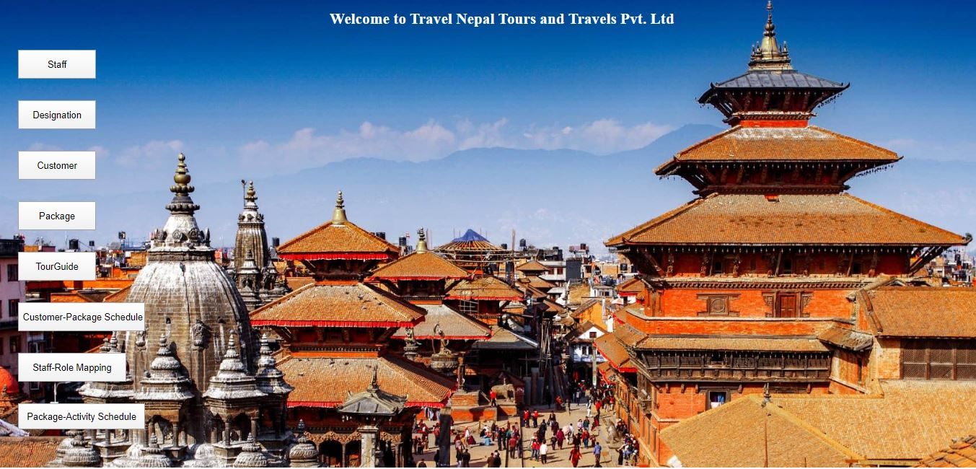

Figure 3 Screenshot of Dashboard

### 6.1.2. Staff Details

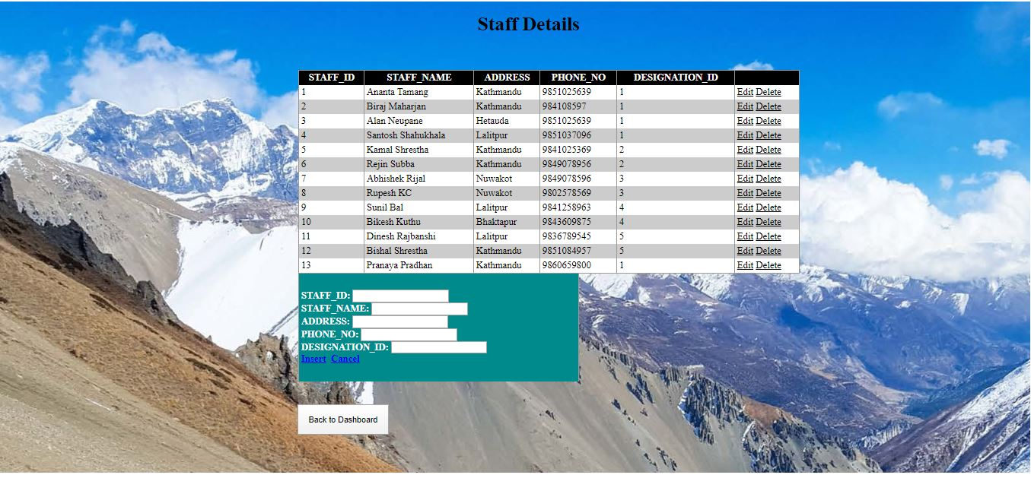

Figure 4 Screenshot of Staff Details Form

### 6.1.3. Designation Details

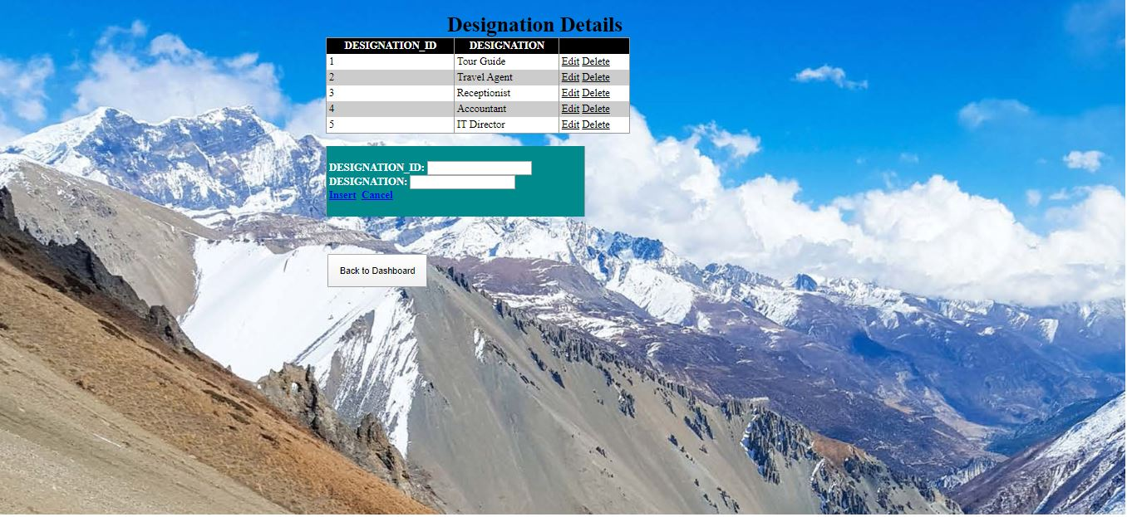

Figure 5 Screenshot of Designation Details Form

### 6.1.4. Customer Details

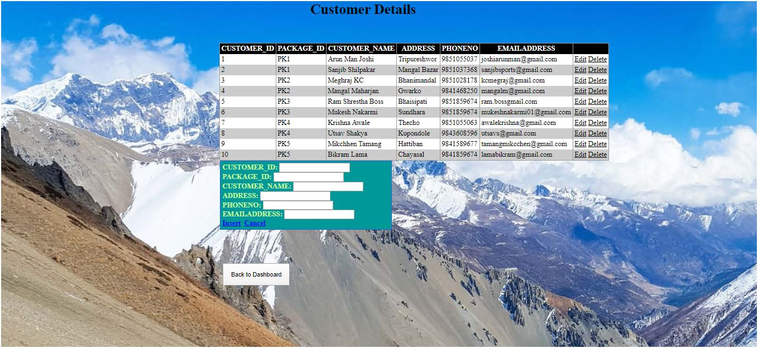

Figure 6 Screenshot of Customer Details Form

### 6.1.5. Package Details

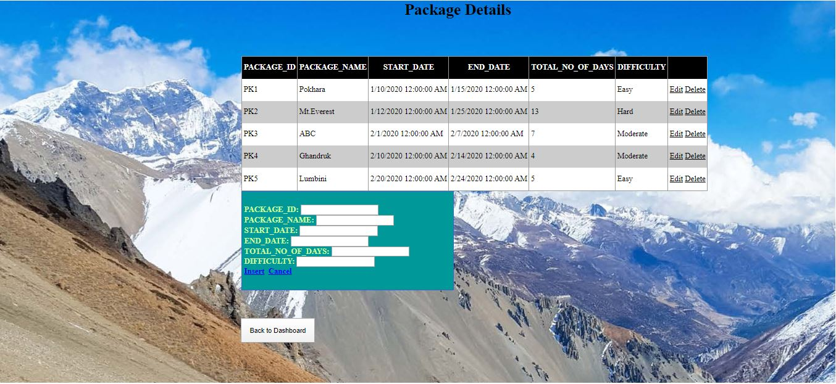

Figure 7 Screenshot of Package Details Form

### 6.1.6. Tour Guide Details

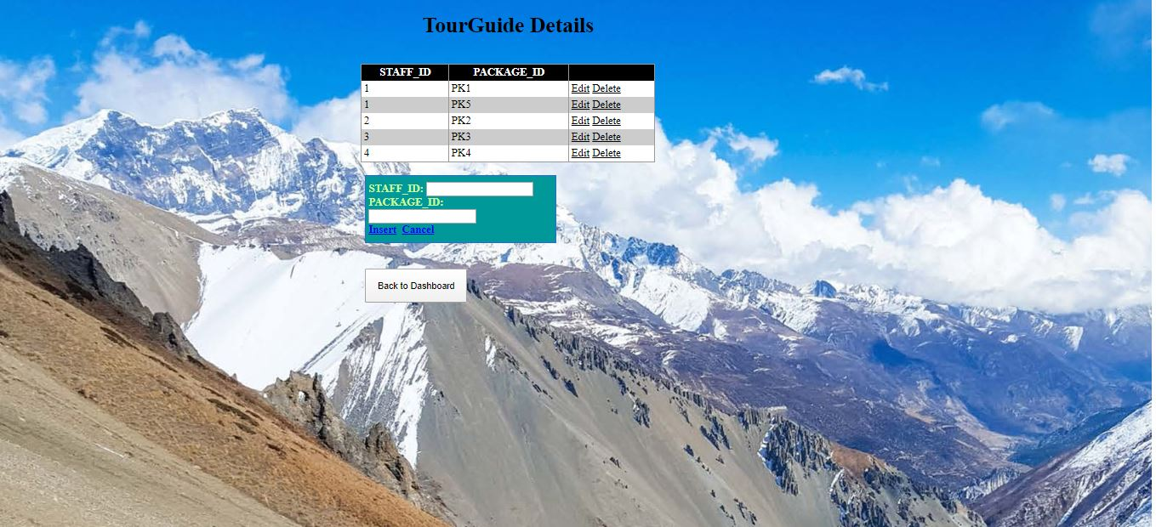

Figure 8 Screenshot of Tour Guide Form

### 6.2. Customer-Package Schedule Form

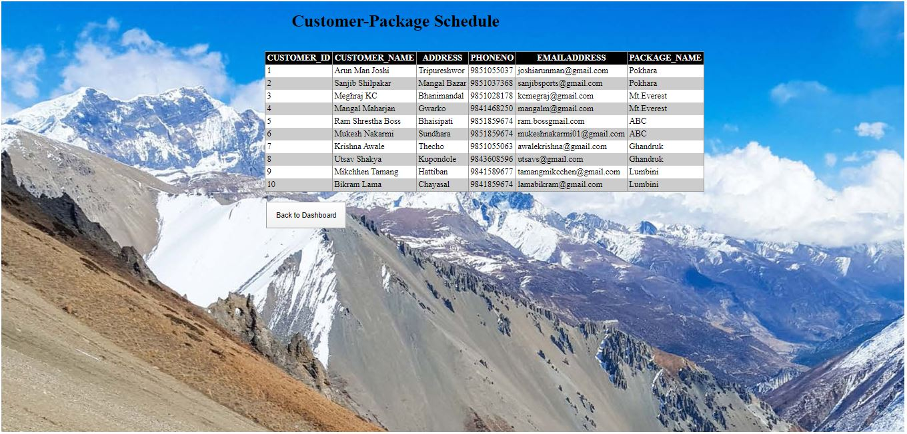

Figure 9 Customer-Package Schedule Form

### 6.3. Staff-Role Schedule Form

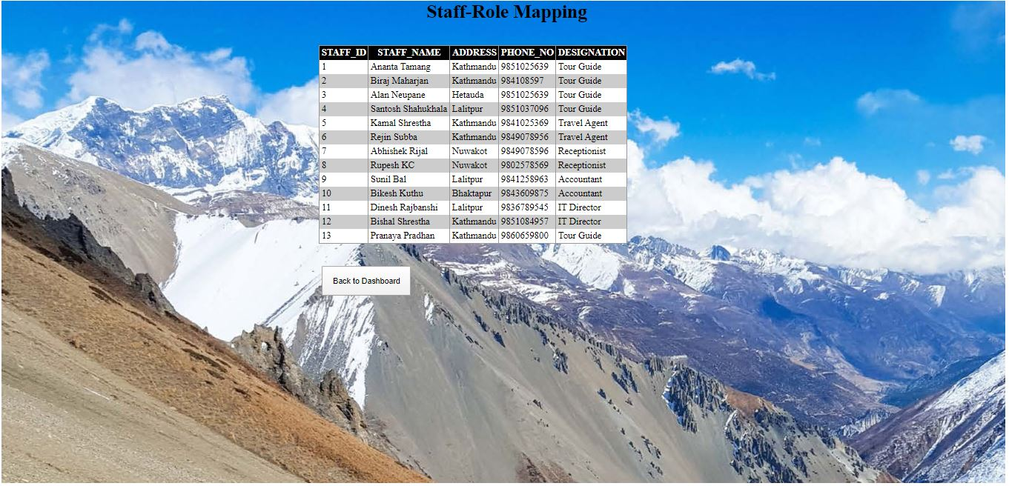

Figure 10 Staff-Role Schedule Form

### 6.4. Package-Activity Schedule Form

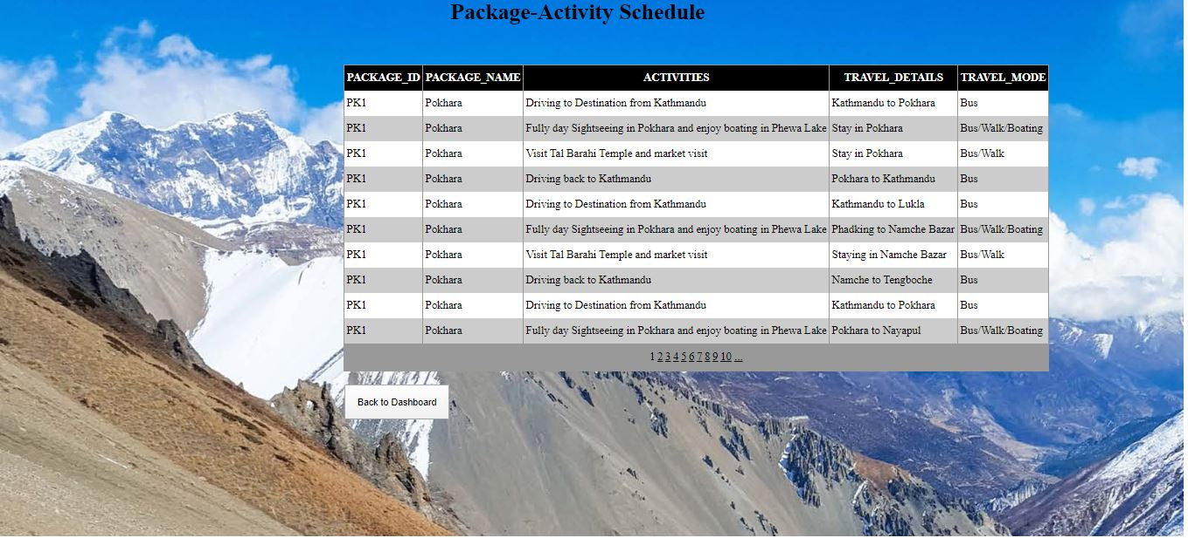

Figure 11 Package-Activity Schedule Form

# 7. Testing

## 7.1. Staff Details

### 7.1.1. Inserting data in Staff Details

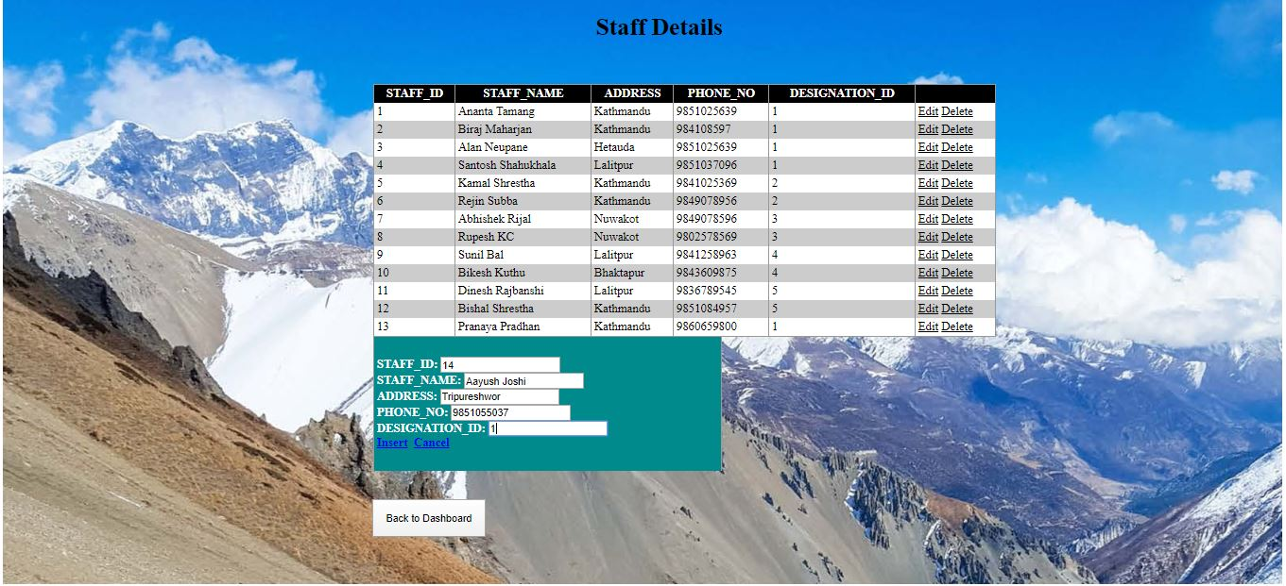

Figure 12 Inserting Data in Customer Text Field

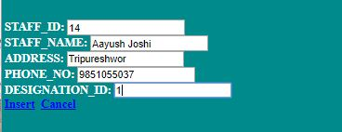

Figure 13 Data Filled in Customer Form Text Field

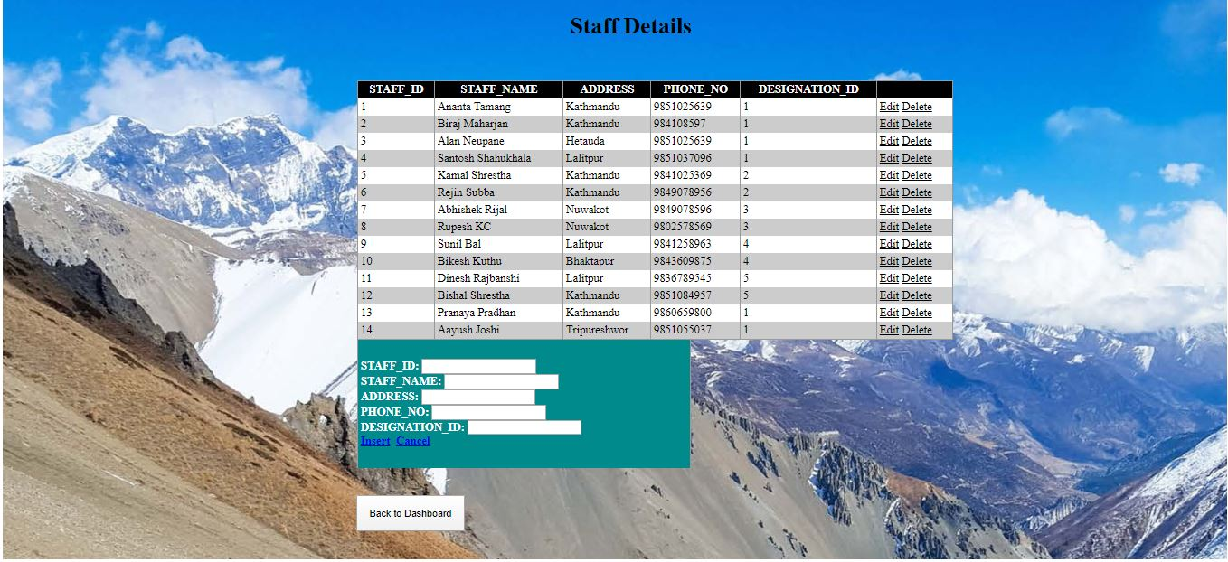

Figure 14 Grid View After Inserting New Data in Customer Form

### 7.1.2. Updating the Data of Grid View

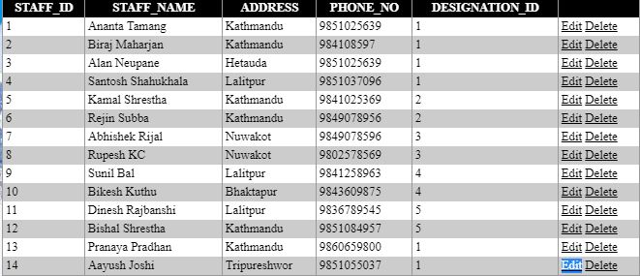

Figure 15 Grid View of Staff Form before Updating the data

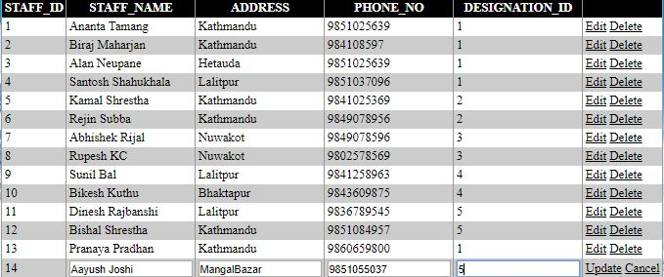

Figure 16 Updating Data in Staff Form

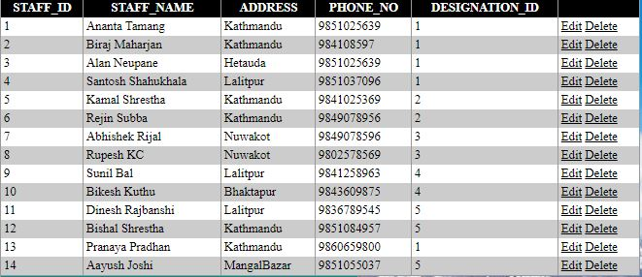

Figure 17 Grid View After Updating the data in Staff Form

### 7.1.3. Deleting the Data of Grid View

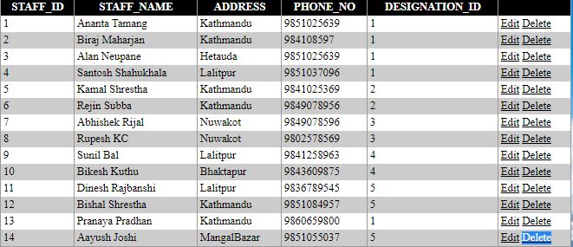

Figure 18 Clicking the Delete button

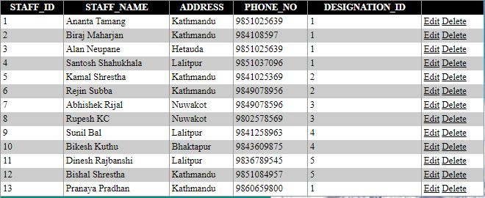

Figure 19 Grid View After Deleting the Data

### 

## 7.2. Designation Form

### 7.2.1. Inserting Data in Designation Form

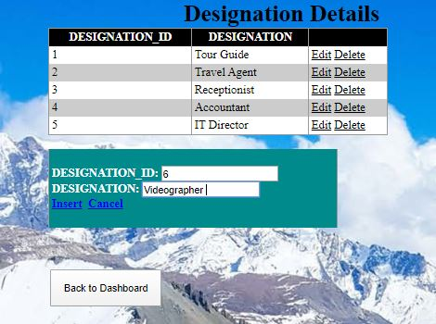

Figure 20 Entering the value in Text Field of Designation Form

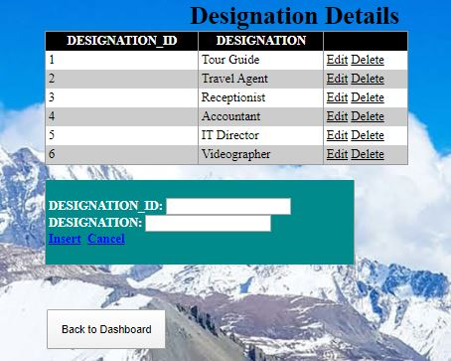

Figure 21 Grid View of Designation Form After Inserting the Data

### 7.2.2. Updating the Data in Designation Form

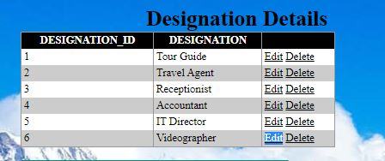

Figure 22 Clicking the Edit Button in Designation Form

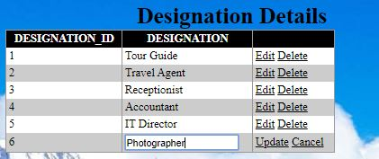

Figure 23 Updating the Data in Designation Form

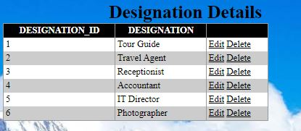

Figure 24 Grid View After Updating the Data

### 7.2.3. Deleting the Data in Designation Form

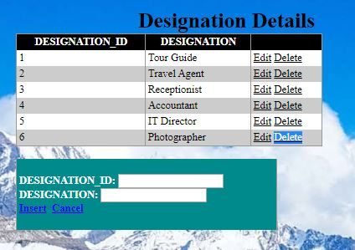

Figure 25 Clicking the Delete Button in Designation Form

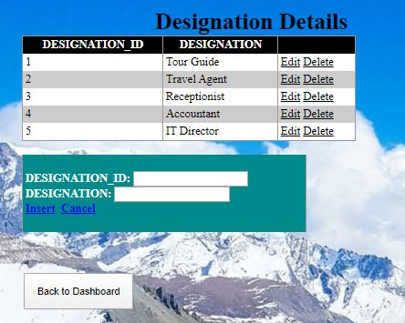

Figure 26 Grid View After Deleting the data in Designation Form

## 7.3. Customer Form

### 7.3.1. Inserting Data in Customer Form

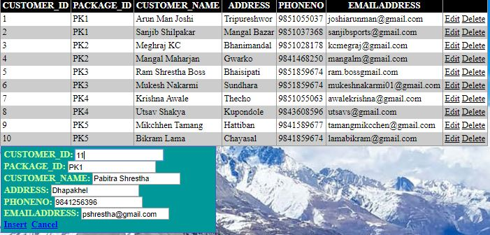

Figure 27 Entering the Data in Text Field of Customer Form

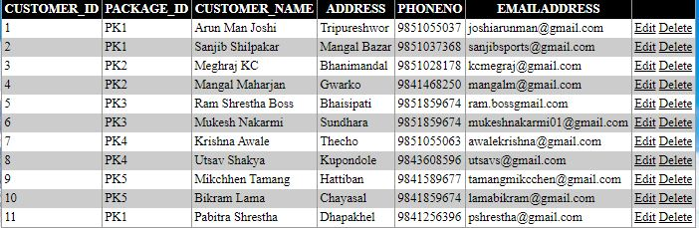

Figure 28 Grid View After Adding New Data in Customer Form

### 7.3.2. Updating the Data in Customer Form

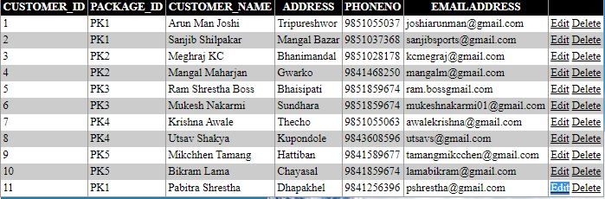

Figure 29 Clicking the Edit Button in Customer Form

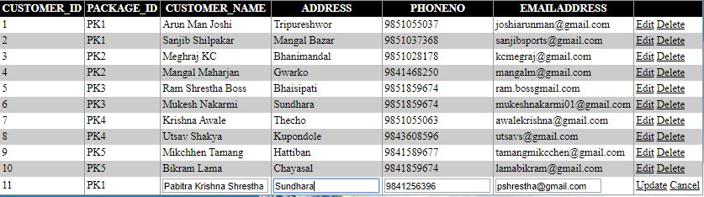

Figure 30 Updating the Data in Grid View of Customer Form

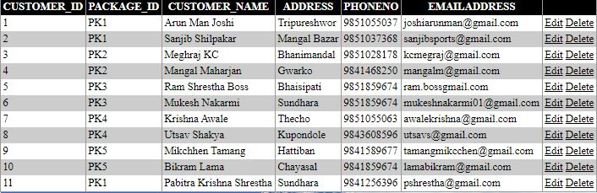

Figure 31 Grid View After Updating the Data in Customer Form

### 7.3.3. Deleting the in Customer Form

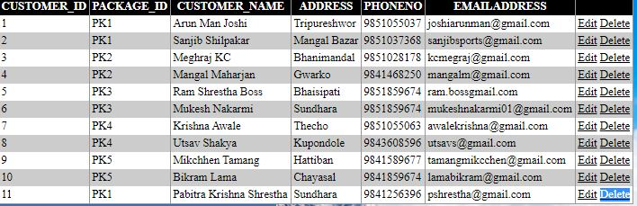

Figure 32 Clicking the Delete Button in Customer Form

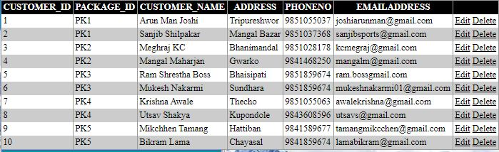

Figure 33 Grid View After Deleting the Data in Customer Form

## 7.4. Package Form

### 7.4.1. Inserting Data in Package Form

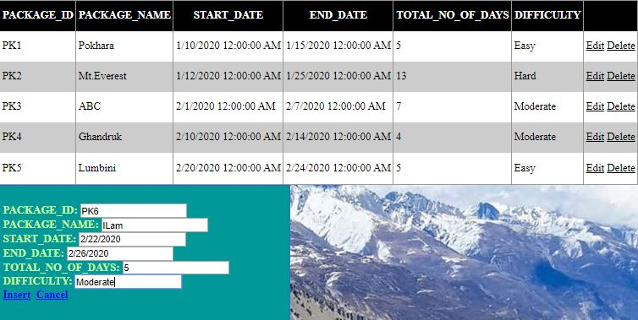

Figure 34 Entering the Data in Text Field of Package Form

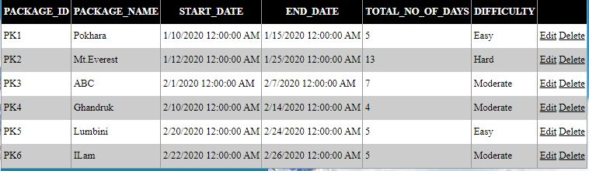

Figure 35 Grid View After Inserting New Data in Package Form

### 7.4.2. Updating the Data in Package Form

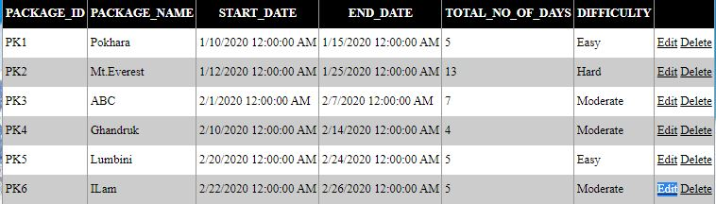

Figure 36 Clicking on Edit Button

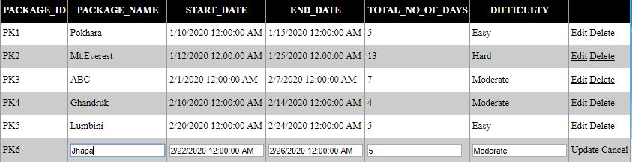

Figure 37 Updating the Data in Grid View of Package Form

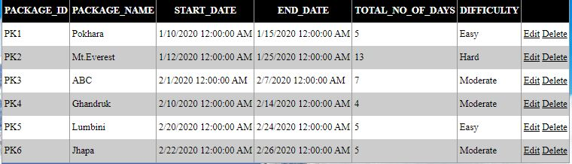

Figure 38 Grid View After Updating the Data in Package Form

### 7.4.3. Deleting the Package Form

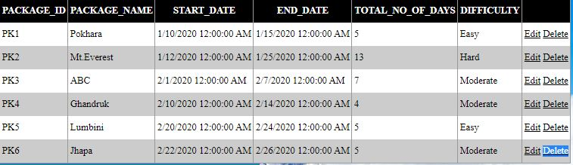

Figure 39 Clicking on Delete Button

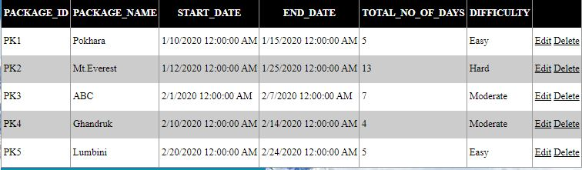

Figure 40 Grid View After Deleting the Data in Package Form

## 7.5. Tour Guide Form

### 7.5.1. Inserting Data in Tour Guide Form

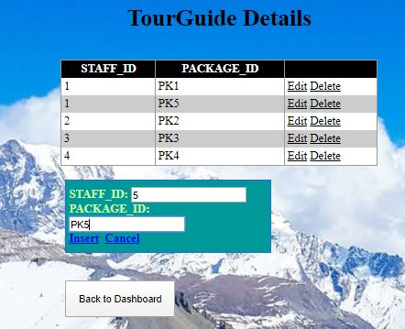

Figure 41 Entering the data in Text Field of TourGuide Forms

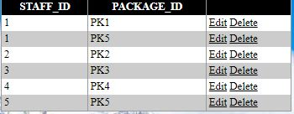

Figure 42 Grid View After Adding Data in TourGuide Form

### 7.5.2. Updating the Data in TourGuide Form

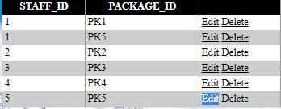

Figure 43 Clicking on Edit Button

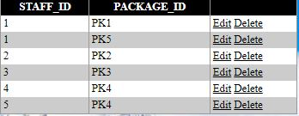

Figure 44 Grid View After Updating the Data on TourGuide Form

### 7.5.3. Deleting the in Tour Guide Form

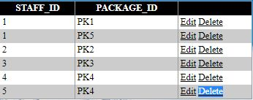

Figure 45 Clicking on Delete Button

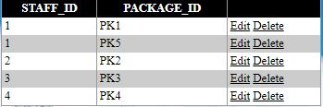

Figure 46 Grid View After Deleting the Data in TourGuide Form

# 8. Further Discussion

his coursework has given me a platform to work on a number of tools and

techniques relating to database and web application development. I have now learnt to

use oracle data modeller, SQL developer and Visual studio for asp.net. This coursework

has helped me enhance my skills in database and ways to connect it with asp.net and

give my application a new look. As this coursework is based on a real time scenario hence

it has helped me think critically on ways to solve the errors encountered and also

development a working application.

While developing this application I faced a number of problems but after working

on the project and searching for the solution I got to know why the error was caused. This

prevented me from making minor errors. I have worked constantly for this project, which

has made to complete this project with precision and produce a complete application that

is made in the ASP.NET along with the implementation of database.

During this coursework I learn new technique on how we can we prepare an ERD

and generate DDL file from there and import it to the SQL Developer. In the SQL

Developer we can write the query to insert new data into the table we have created and

this can be easily connect to all our web pages through an easily step. In this project I

also learn to work on asp.net that was quite a new topic for me. But after working on it

and going through tutorials i was able to complete the task assigned

First ever coursework has given me a platform to work on a number of tools and techniques relating to database and web application development. I have now learnt to use oracle data modeller, SQL developer and Visual studio for asp.net. This coursework has helped me enhance my skills in database and ways to connect it with asp.net and give my application a new look. As this coursework is based on a real time scenario hence it has helped me think critically on ways to solve the errors encountered and also development a working application. While developing this application I faced a number of problems but after working on the project and searching for the solution I got to know why the error was caused. This prevented me from making minor errors. I have worked constantly for this project, which has made to complete this project with precision and produce a complete application that is made in the ASP.NET along with the implementation of database. During this coursework I learn new technique on how we can we prepare an ERD and generate DDL file from there and import it to the SQL Developer. In the SQL Developer we can write the query to insert new data into the table we have created and this can be easily connect to all our web pages through an easily step. In this project I also learn to work on asp.net that was quite a new topic for me. But after working on it and going through tutorials i was able to complete the task assigned at the end.